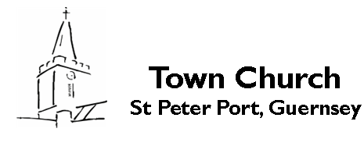

**Town Church**

**St Peter Port, Guernsey**

**The First Sunday of Lent**

Sung Eucharist

**Sunday 9th March 2025**

**Welcome** to Town Church. Whether you are a regular or occasional visitor, we are pleased to have you as part of our worshipping community today. We hope you enjoy the service. Please join us for tea or coffee at the end of the service in the South Aisle

**Bienvenue** dans notre église dédiée à Saint-Pierre, mais connue sous le nom de "Town Church". Nous sommes heureux de vous accueillir à notre messe aujourd'hui. Nous espérons que vous apprécierez le service. Nous vous invitons à rester pour prendre le thé ou le café à la fin de la messe.

**Laipni lūdzam** St Peter Port baznīcā, ko sauc arī par Pilsētas baznīcu. Mēs priecājamies, ka esat izvēlējies (-usies) būt kopā ar mums šajā dievkalpojumā un ceram, ka Jums tas patiks. Lūdzam kopā ar mums iebaudīt tēju vai kafiju pēc dievkalpojuma.

**Willkommen** in unserer Kirche, die Sankt Petrus geweiht, aber als’Stadtkirche’ bekannt ist. Wir freuen uns, dass Sie sich entschlossen haben, an unserer Eucharistiefeier teilzunehmen und hoffen dass Ihnen unser Gottesdienst gefällt. Bitte bleiben Sie am Ende noch bei uns zu Kaffee oder Tee.

**Large Print Orders of Service**

Please ask one of the welcomers if you would like one.

**Contactless Card payments**

If you would like to make donations via contactless card/phone there is a machine by the door.

**Communion**

If you need communion bringing to you in your place, or require a gluten-free wafer, please ask one of the sidespersons before the service, who will be pleased to arrange this.

**Music**

The Organist and Director of Music is Stephen Le Prevost. The musical setting for the service is the Mass of the bread of life by Margaret Rizza.

*Some material included in this service is copyright:*

*© The Archbishops' Council 2000 © The Archbishops' Council 2007*

*Copyright hymns in this service are reproduced under CCL Licence Number 2328071*

*The Gathering*

*Please stand to sing the opening hymn (HON 426)*

**Praise to the Holiest in the height,**

**and in the depth be praise:**

**in all his words most wonderful,**

**most sure in all his ways.**

**O loving wisdom of our God!**

**when all was sin and shame,**

**a second Adam to the fight,**

**and to the rescue came.**

**O wisest love! that flesh and blood,**

**which did in Adam fail,**

**should strive afresh against the foe,**

**should strive and should prevail.**

**And that a higher gift than grace**

**should flesh and blood refine,**

**God’s presence and his very self,**

**and essence all divine.**

**And in the garden secretly,**

**and on the cross on high,**

**should teach his brethren, and inspire**

**to suffer and to die.**

**Praise to the Holiest in the height,**

**and in the depth be praise;**

**in all his words most wonderful,**

**most sure in all his ways.**

*John Henry Newman (1801-1890)*

*The president says*

In the name of the Father,

and of the Son,

and of the Holy Spirit.

*All* **Amen**

**The Greeting**

*The president greets the people*

Grace, mercy and peace

from God our Father

and the Lord Jesus Christ

be with you

*All* **And also with you.**

*Further words of welcome or introduction may be said*

**Prayer of Preparation**

*All* **Almighty God,**

**to whom all hearts are open,**

**all desires known,**

**and from whom no secrets are hidden:**

**cleanse the thoughts of our hearts**

**by the inspiration of your Holy Spirit,**

**that we may perfectly love you,**

**and worthily magnify your holy name;**

**through Christ our Lord.**

**Amen.**

*Please sit or kneel*

**Prayers of Penitence**

*A minister says the invitation to confession*

The sacrifice of God is a broken spirit;

a broken and contrite heart God will not despise.

Let us come to the Lord, who is full of compassion,

and acknowledge our transgressions

in penitence and faith.

*All* **Most merciful God,  
Father of our Lord Jesus Christ,  
we confess that we have sinned  
in thought, word and deed.  
We have not loved you with our whole heart.  
We have not loved our neighbours as ourselves.  
In your mercy  
forgive what we have been,  
help us to amend what we are,  
and direct what we shall be;  
that we may do justly,  
love mercy,  
and walk humbly with you, our God.**

**Amen.**

**Kyrie**

*Please remain seated while we sing the Kyrie*

*The president says*

Almighty God,

who forgives all who truly repent,

have mercy upon you,

pardon and deliver you from all your sins,

confirm and strengthen you in all goodness,

and keep you in life eternal;

through Jesus Christ our Lord.

*All* **Amen.**

**The Collect**

*The president introduces a period of silent prayer with the words,*

Let us pray.

Almighty God,

whose Son Jesus Christ fasted forty days in the wilderness,

and was tempted as we are, yet without sin:

give us grace to discipline ourselves

in obedience to your Spirit;

and, as you know our weakness,

so may we know your power to save;

through Jesus Christ your Son our Lord,

who is alive and reigns with you,

in the unity of the Holy Spirit,

one God, now and for ever.

*All* **Amen**

*Please sit*

**Old Testament Reading**

*Deuteronomy 26.1–11*

*A reading from the Book of Deuteronomy*

Moses said to all Israel: When you have come into the land that the Lord your God is giving you as an inheritance to possess, and you possess it, and settle in it, you shall take some of the first of all the fruit of the ground, which you harvest from the land that the Lord your God is giving you, and you shall put it in a basket and go to the place that the Lord your God will choose as a dwelling for his name.

You shall go to the priest who is in office at that time, and say to him, ‘Today I declare to the Lord your God that I have come into the land that the Lord swore to our ancestors to give us.’ When the priest takes the basket from your hand and sets it down before the altar of the Lord your God, you shall make this response before the Lord your God: ‘A wandering Aramean was my ancestor; he went down into Egypt and lived there as an alien, few in number, and there he became a great nation, mighty and populous. When the Egyptians treated us harshly and afflicted us, by imposing hard labour on us, we cried to the Lord, the God of our ancestors; the Lord heard our voice and saw our affliction, our toil, and our oppression. The Lord brought us out of Egypt with a mighty hand and an outstretched arm, with a terrifying display of power, and with signs and wonders; and he brought us into this place and gave us this land, a land flowing with milk and honey. So now I bring the first of the fruit of the ground that you, O Lord, have given me.’ You shall set it down before the Lord your God and bow down before the Lord your God.

Then you, together with the Levites and the aliens who reside among you, shall celebrate with all the bounty that the Lord your God has given to you and to your house.

Let us bless the Lord.

*All*  **Thanks be to God.**

**Psalm 91.1-11**

*The response is sung first by the choir, then repeated by everyone. The choir sings the verses and all join in the response between each verse.*

1. 1 Whoever dwells in the shelter of | the Most High

and abides under the shadow of | the Almighty,

2 Shall say to the Lord, ‘My refuge | and my stronghold,

my God, in whom I | put my trust.’

1. 3 For he shall deliver you from the snare | of the fowler

and from the | deadly pestilence.

4 He shall cover you with his wings

and you shall be safe un | der his feathers;

his faithfulness shall be your | shield and buckler.

1. 5 You shall not be afraid of any ter | ror by night,

nor of the arrow that | flies by day;

6 Of the pestilence that | stalks in darkness,

nor of the sickness that des | troys at noonday.

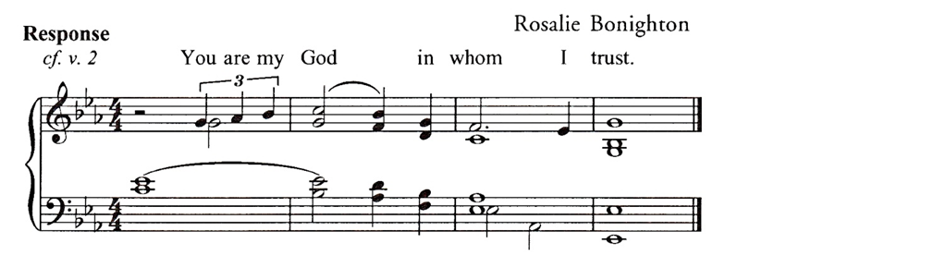

1. 7 Though a thousand fall at your side

and ten thousand | at your right hand,

yet it shall | not come near you.

8 Your eyes have only | to behold

to see the reward | of the wicked.

1. 9 Because you have made the | Lord your refuge

and the Most | High your stronghold,

10 There shall no | evil happen to you,

neither shall any plague come | near your tent.

1. 11 For he shall give his angels charge | over you,

to keep you in | all your ways.

**New Testament Reading**

*Romans 10.8b–13*

*A reading from the letter to the Romans*

But what does it say?

‘The word is near you,

on your lips and in your heart’

(that is, the word of faith that we proclaim); because if you confess with your lips that Jesus is Lord and believe in your heart that God raised him from the dead, you will be saved. For one believes with the heart and so is justified, and one confesses with the mouth and so is saved. The scripture says, ‘No one who believes in him will be put to shame.’ For there is no distinction between Jew and Greek; the same Lord is Lord of all and is generous to all who call on him. For, ‘Everyone who calls on the name of the Lord shall be saved.’

Let us bless the Lord.

*All*  **Thanks be to God.**

**Gospel Reading**

*Luke 4.1–13*

*Please stand and turn to face the Gospel reader.*

Praise to you, O Christ, King of eternal glory.

*All***Praise to you, O Christ, King of eternal glory.**

The Lord is a great God,

O that today you would listen to his voice.

Harden not your hearts.

*All* **Praise to you, O Christ, King of eternal glory.**

The Lord be with you

*All* **and also with you**

Hear the Gospel of our Lord Jesus Christ

according to Luke

*All* **Glory to you, O Lord.**

Jesus, full of the Holy Spirit, returned from the Jordan and was led by the Spirit in the wilderness, where for forty days he was tempted by the devil. He ate nothing at all during those days, and when they were over, he was famished. The devil said to him, ‘If you are the Son of God, command this stone to become a loaf of bread.’ Jesus answered him, ‘It is written, “One does not live by bread alone.” ’

Then the devil led him up and showed him in an instant all the kingdoms of the world. And the devil said to him, ‘To you I will give their glory and all this authority; for it has been given over to me, and I give it to anyone I please.

If you, then, will worship me, it will all be yours.’

Jesus answered him, ‘It is written,

“Worship the Lord your God,

and serve only him.” ’

Then the devil took him to Jerusalem, and placed him on the pinnacle of the temple, saying to him, ‘If you are the Son of God, throw yourself down from here, for it is written,

“He will command his angels concerning you,

to protect you”,

and

“On their hands they will bear you up,

so that you will not dash your foot against a stone.” ’

Jesus answered him, ‘It is said, “Do not put the Lord your God to the test.” ’ When the devil had finished every test, he departed from him until an opportune time.

This is the Gospel of the Lord.

*All* **Praise to you, O Christ.**

**Sermon**

*Please sit.*

**The Creed**

*Please stand when the president stands*

*All* **We believe in one God,  
the Father, the Almighty,  
maker of heaven and earth,  
of all that is, seen and unseen.**

**We believe in one Lord, Jesus Christ,  
the only Son of God,  
eternally begotten of the Father,  
God from God, Light from Light,  
true God from true God,  
begotten, not made,  
of one Being with the Father;  
through him all things were made.**

**For us and for our salvation**

**he came down from heaven,  
was incarnate from the Holy Spirit and the Virgin Mary**

**and was made human.**

**For our sake he was crucified under Pontius Pilate;**

**he suffered death and was buried.**

**On the third day he rose again**

**in accordance with the Scriptures;**

**he ascended into heaven**

**and is seated at the right hand of the Father.**

**He will come again in glory**

**to judge the living and the dead,**

**and his kingdom will have no end.**

**We believe in the Holy Spirit,**

**the Lord, the giver of life,**

**who proceeds from the Father and the Son,**

**who with the Father and the Son**

**is worshipped and glorified,**

**who has spoken through the prophets.**

**We believe in one holy catholic and apostolic Church.**

**We acknowledge one baptism**

**for the forgiveness of sins.**

**We look for the resurrection of the dead,**

**and the life of the world to come. Amen.**

**Prayers of Intercession**

*Please sit or kneel.*

*At the end of each bidding the following response is used*

Lord, hear us

*All* **Lord, graciously hear us**

*And at the end this ending is used.*

Merciful Father

*All* **accept these prayers**

**for the sake of your Son,**

**our Saviour Jesus Christ.**

**Amen.**

*The Liturgy of the Sacrament*

**The Peace**

*Please stand. The president introduces the peace*

Since we are justified by faith,

we have peace with God through our Lord Jesus Christ,

who has given us access to his grace.

The peace of the Lord be always with you

*All* **and also with you.**

Let us offer one another a sign of peace.

*All may exchange a sign of peace*

**Preparation of the Table**

**Taking of the Bread and Wine**

*During the following hymn (HON 39), a collection is taken, the table is prepared and bread and wine are placed upon it. If you wish to donate, but do not have cash; contactless card/phone payments can be made after the service, by the door.*

**As the deer pants for the water,**

**so my soul longs after you.**

**You alone are my heart's desire**

**and I long to worship you.**

**You alone are my strength, my shield,**

**to you alone may my spirit yield.**

**You alone are my heart's desire**

**and I long to worship you.**

**I want you more than gold or silver,**

**only you can satisfy.**

**You alone are the real joy-giver**

**and the apple of my eye.**

**You alone are my strength, my shield,**

**to you alone may my spirit yield.**

**You alone are my heart's desire**

**and I long to worship you.**

**You're my Friend and you're my brother,**

**even though you are a king.**

**I love you more than any other,**

**so much more than anything.**

**You alone are my strength, my shield,**

**to you alone may my spirit yield.**

**You alone are my heart's desire**

**and I long to worship you.**

*The president receives the prayer cards which have been left in the church by visitors during the past week.*

We come to you, loving God seeking your grace,  
we offer to you the people

of many different races, cultures and beliefs

who have used this holy place in recent days.  
We bring before you the concern on their hearts,   
the thoughts in their heads  
and the situations for which they have prayed.  
And now we offer you our concerns  
that as we receive this sacrament of bread and wine;  
your grace may lead us on the journey which is before us.  
In Christ’s name we pray.

*All* **Amen.**

God of mercy and compassion,

your Word calls us home to faith and love.

accept all we offer you this day;

in the name of Jesus Christ the Lord.

*All* **Amen**

*The president takes the bread and the wine*

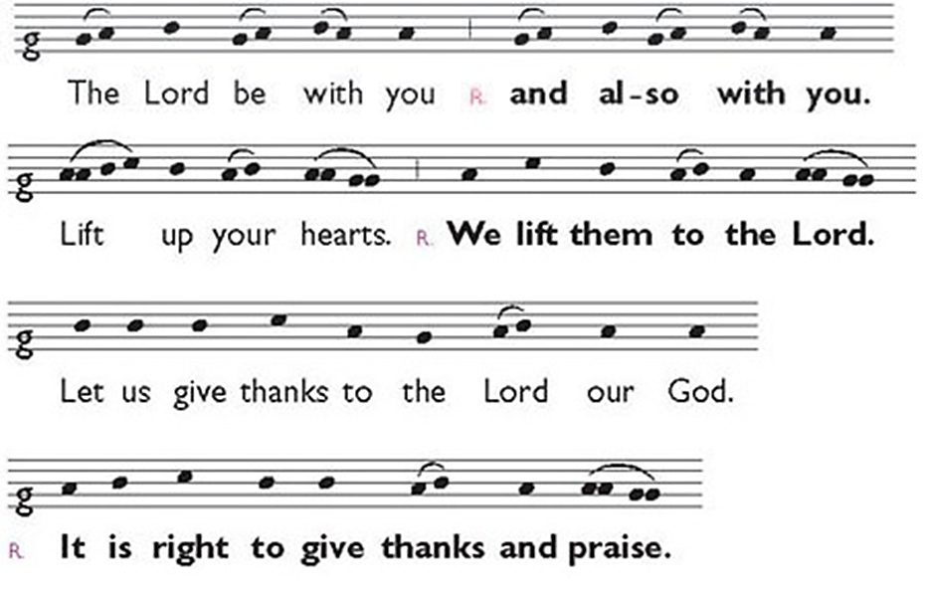**The Eucharistic Prayer**

It is indeed right and good

to give you thanks and praise,

almighty God and everlasting Father,

through Jesus Christ your Son.

For in these forty days

you lead us into the desert of repentance

that through a pilgrimage of prayer and discipline

we may grow in grace

and learn to be your people once again.

Through fasting, prayer and acts of service

you bring us back to your generous heart.

Through study of your holy word

you open our eyes to your presence in the world

and free our hands to welcome others

into the radiant splendour of your love.

As we prepare to celebrate the Easter feast

with joyful hearts and minds

we bless you for your mercy

and join with saints and angels

for ever praising you and singing:

*Please sit or kneel*

Lord, you are holy indeed, the source of all holiness;

grant that by the power of your Holy Spirit,

and according to your holy will,

these gifts of bread and wine

may be to us the body and blood of our Lord Jesus Christ;

who, in the same night that he was betrayed,

took bread and gave you thanks;

he broke it and gave it to his disciples, saying:

Take, eat; this is my body which is given for you;

do this in remembrance of me.

In the same way, after supper

he took the cup and gave you thanks;

he gave it to them, saying:

Drink this, all of you;

this is my blood of the new covenant,

which is shed for you and for many

for the forgiveness of sins.

Do this, as often as you drink it,

in remembrance of me.

Christ is the Bread of Life:

All **When we eat this bread and drink this cup,**

**we proclaim your death, Lord Jesus,**

**until you come in glory.**

And so, Father, calling to mind his death on the cross,

his perfect sacrifice made once

for the sins of the whole world;

rejoicing in his mighty resurrection

and glorious ascension,

and looking for his coming in glory,

we celebrate this memorial of our redemption.

As we offer you this our sacrifice

of praise and thanksgiving,

we bring before you this bread and this cup

and we thank you for counting us worthy

to stand in your presence and serve you.

Send the Holy Spirit on your people

and gather into one in your kingdom

all who share this one bread and one cup,

so that we, in the company of the Blessed Virgin Mary,

and all the saints,

may praise and glorify you for ever,

through Jesus Christ our Lord;

by whom, and with whom, and in whom,

in the unity of the Holy Spirit,

all honour and glory be yours, almighty Father,

for ever and ever.

*All* **Amen.**

**The Lord’s Prayer**

*A short silence is kept before we pray the Lord’s Prayer in our first language whichever that may be.*

*Nous récitons le Notre Père dans notre langue maternelle.*

*Mēs lūdzam Tēvreizi katrs savā dzimtajā valodā.*

*Wir beten das Vaterunser in unserer Muttersprache.*

As we join our prayers with the Church Universal,

so we say, each in our own language, the prayer that Jesus taught us.

*All*  **Our Father, who art in heaven** *Notre Père….*

**hallowed be thy name;**

**thy kingdom come;** *Vater Unser….*

**thy will be done;**

**on earth as it is in heaven.** *Mūsu Tēvs ….*

**Give us this day our daily bread.**

**And forgive us our trespasses,** *Padre Nuestro….*

**as we forgive those**

**who trespass against us.** *Pai Nosso….*

**And lead us not into temptation;**

**but deliver us from evil.** *Onze Vader….*

**For thine is the kingdom,**

**the power and the glory,** *Ein Tad….*

**for ever and ever.**

**Amen.** *Ojcze Nasz….*

**Breaking of the Bread**

*The president breaks the consecrated bread.*

Every time we eat this bread

and drink this cup

*All*  **we proclaim the Lord’s death**

**until he comes.**

**Agnus Dei**

*We sing the Agnus Dei as the bread is broken.*

**Giving of Communion**

*The president says the following invitation to communion*

Draw near with faith.

Receive the body of our Lord Jesus Christ

which he gave for you,

and his blood which he shed for you.

Eat and drink

in remembrance that Christ died for you,

and feed on him in your hearts

by faith with thanksgiving.

*All those who wish to receive communion are welcome to receive communion here today. Please receive the bread, then move to the right to receive the chalice or left for the pipette. If you do not wish to receive communion but would like a blessing, please come forward with everyone else and hold this service booklet in your hands as an indication of this wish. If you do not want to do either of these then, please feel free to stay in your seat*.

*The president and people receive communion.*

**Communion Anthem**

‘In my Father’s House’ *Stopford*

**Prayer after Communion**

*Please sit or kneel*

Lord God,

you have renewed us with the living bread from heaven;

by it you nourish our faith,

increase our hope,

and strengthen our love:

teach us always to hunger for him

who is the true and living bread,

and enable us to live by every word

that proceeds from out of your mouth;

through Jesus Christ our Lord.

*All*  **Amen.**

*All* **God of our pilgrimage,**

**you have fed us with the bread of heaven.**

**Refresh and sustain us**

**as we go forward on our journey,**

**in the name of Jesus Christ our Lord.**

**Amen.**

*Notices may be given*

*The Dismissal*

**Final Hymn (HON 388)**

**O praise ye the Lord! praise him in the height;  
rejoice in his word, ye angels of light;  
ye heavens, adore him, by whom ye were made,  
and worship before him, in brightness arrayed.  
  
O praise ye the Lord! praise him upon earth,  
in tuneful accord, all you of new birth;  
praise him who hath brought you his grace from above,  
praise him who hath taught you to sing of his love.  
  
O praise ye the Lord! all things that give sound;  
each jubilant chord re-echo around;  
loud organs his glory forth tell in deep tone,  
and sweet harp, the story of what he hath done.  
  
O praise ye the Lord! thanksgiving and song  
to him be outpoured all ages along:  
for love in creation, for heaven restored.  
for grace of salvation, O praise ye the Lord!**

*Henry Williams Baker (1821-1877)*

**The Blessing**

*The president says*

God, who from the death of sin

raised you to new life in Christ,

keep you from falling

and set you in the presence of his glory;

and the blessing of God almighty,

the Father, the Son, and the Holy Spirit,

be among you and remain with you always.

*All***Amen.**

*A minister says*

Go in peace to love and serve the Lord.

*All*  **In the name of Christ, Amen.**

**Organ Voluntary**

‘Postlude in D minor’Stanford

***Please join us for refreshments in the South Aisle***

**WHAT’S ON THIS WEEK**

|  |  |
| --- | --- |
| **Morning Prayer**  (in church + online by request)  **7.45 am** Monday to Thursday | **Evening Prayer**  (in church)  **5.30 pm** Monday to Thursday |

**Tuesday 11th March**

**7 pm** The Lent Group

**Wednesday 12th March**

**10 am – 12 pm** Wednesday Welcome

**Thursday 13th March**

**1.10 pm** Come to the Quiet

Said Eucharist with reflective music.

**Next Sunday 16th March**

**8 am** Said Eucharist (BCP)

**11 am** Choral Eucharist

**6.30 pm** Choral Evensong

For more details about the life of Town Church please visit our website [www.townchurch.net](http://www.townchurch.net) or 

**@TownChurchGsy**

**Churchwardens**

Ruth Abernethy 07781 181281 ruth_abernethy@hotmail.com

Sally Henderson 07781 117266 sallyelizabethhenderson@hotmail.com

**Rector**

The Revd Penny Graysmith

Tel: 01481 715641

penny.graysmith@deanery.gg

**Associate Priest**

The Revd Peter Graysmith

Tel: 01481 715641

peter.graysmith@deanery.gg